**Q1.**

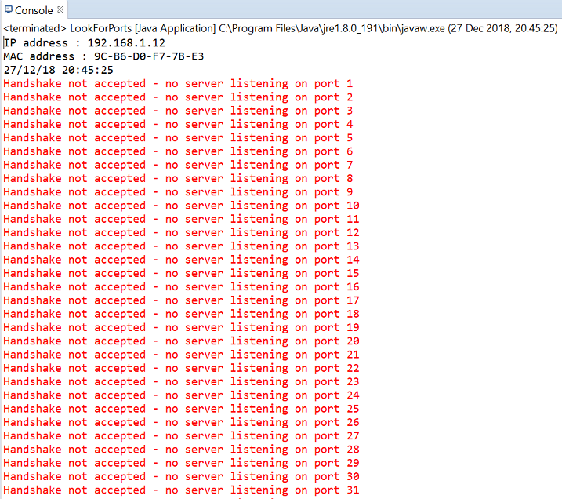

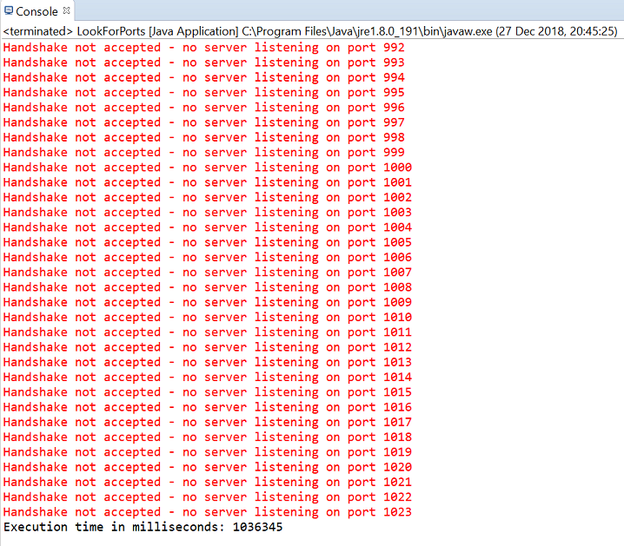

**Q2.**

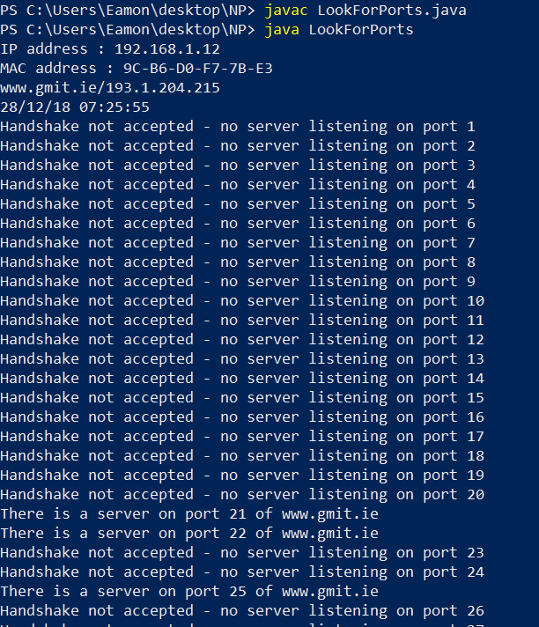

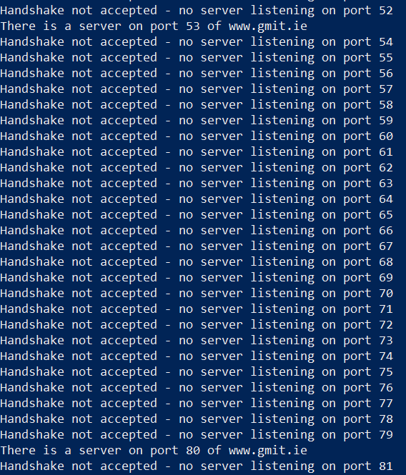

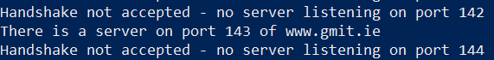

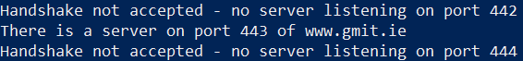

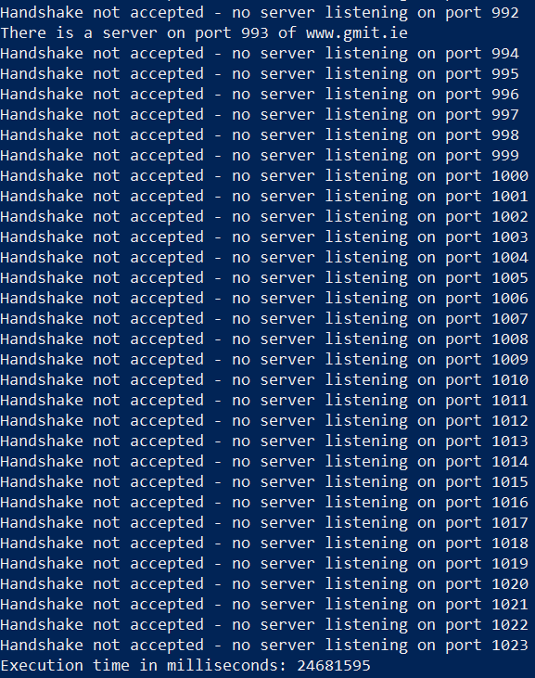

**Q3.**

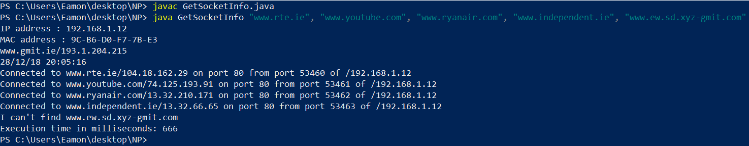

I decided to run Q1. In eclipse and Q2. & Q3. from the PowerShell command prompt to demonstrate that I can run java programmes using both methods and because it wasn’t specified whether we should use a command prompt or an IDE to run our programmes.

For Q1. I used the Windows Snipping Tool to show the start and the end of the programme output. For Q2., as well as showing the start and end of the programme output, I also snipped any section of the output that showed a port with an active server.

For Q3. I was unsure whether the ‘Target IP Address’ - in the case of my programme: [www.gmit.ie](http://www.gmit.ie) - should be one of the self-selected first four, so I decided to select four that didn’t include my target IP address.